Guide screen (DANGER, Safe, Secret Code etc.)

In mission screen

C:\Users\Tom\Desktop\dez\energy_symbol.png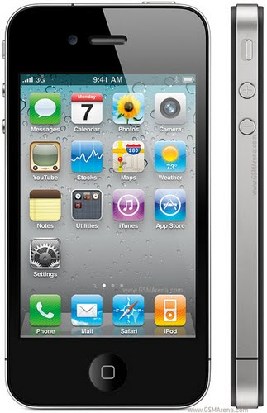C:\Users\Tom\Desktop\dez\energy_symbol.png

**1,654**

**ENERGY POINTS**

**1,654**

**ENERGY POINTS**

**MISSION LOG**



**ZONE OF EXCLUSION**

**OUT OF THE ZONE**

**BOMB**

**DISARMED**

**ARMOR COLLECTED**

**GUARDS AFTER YOU!**

Capsule and Item collected Screens



C:\Users\Tom\Desktop\dez\energy_symbol.pngC:\Users\Tom\Desktop\dez\energy_symbol.png

**1,654**

**ENERGY POINTS**

**ENERGY POINTS**

**1,654**

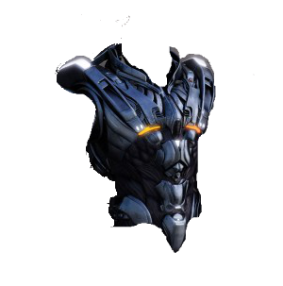



**ARMOR COLLECTED**

**SUPPLY CAPSULE AHEAD**